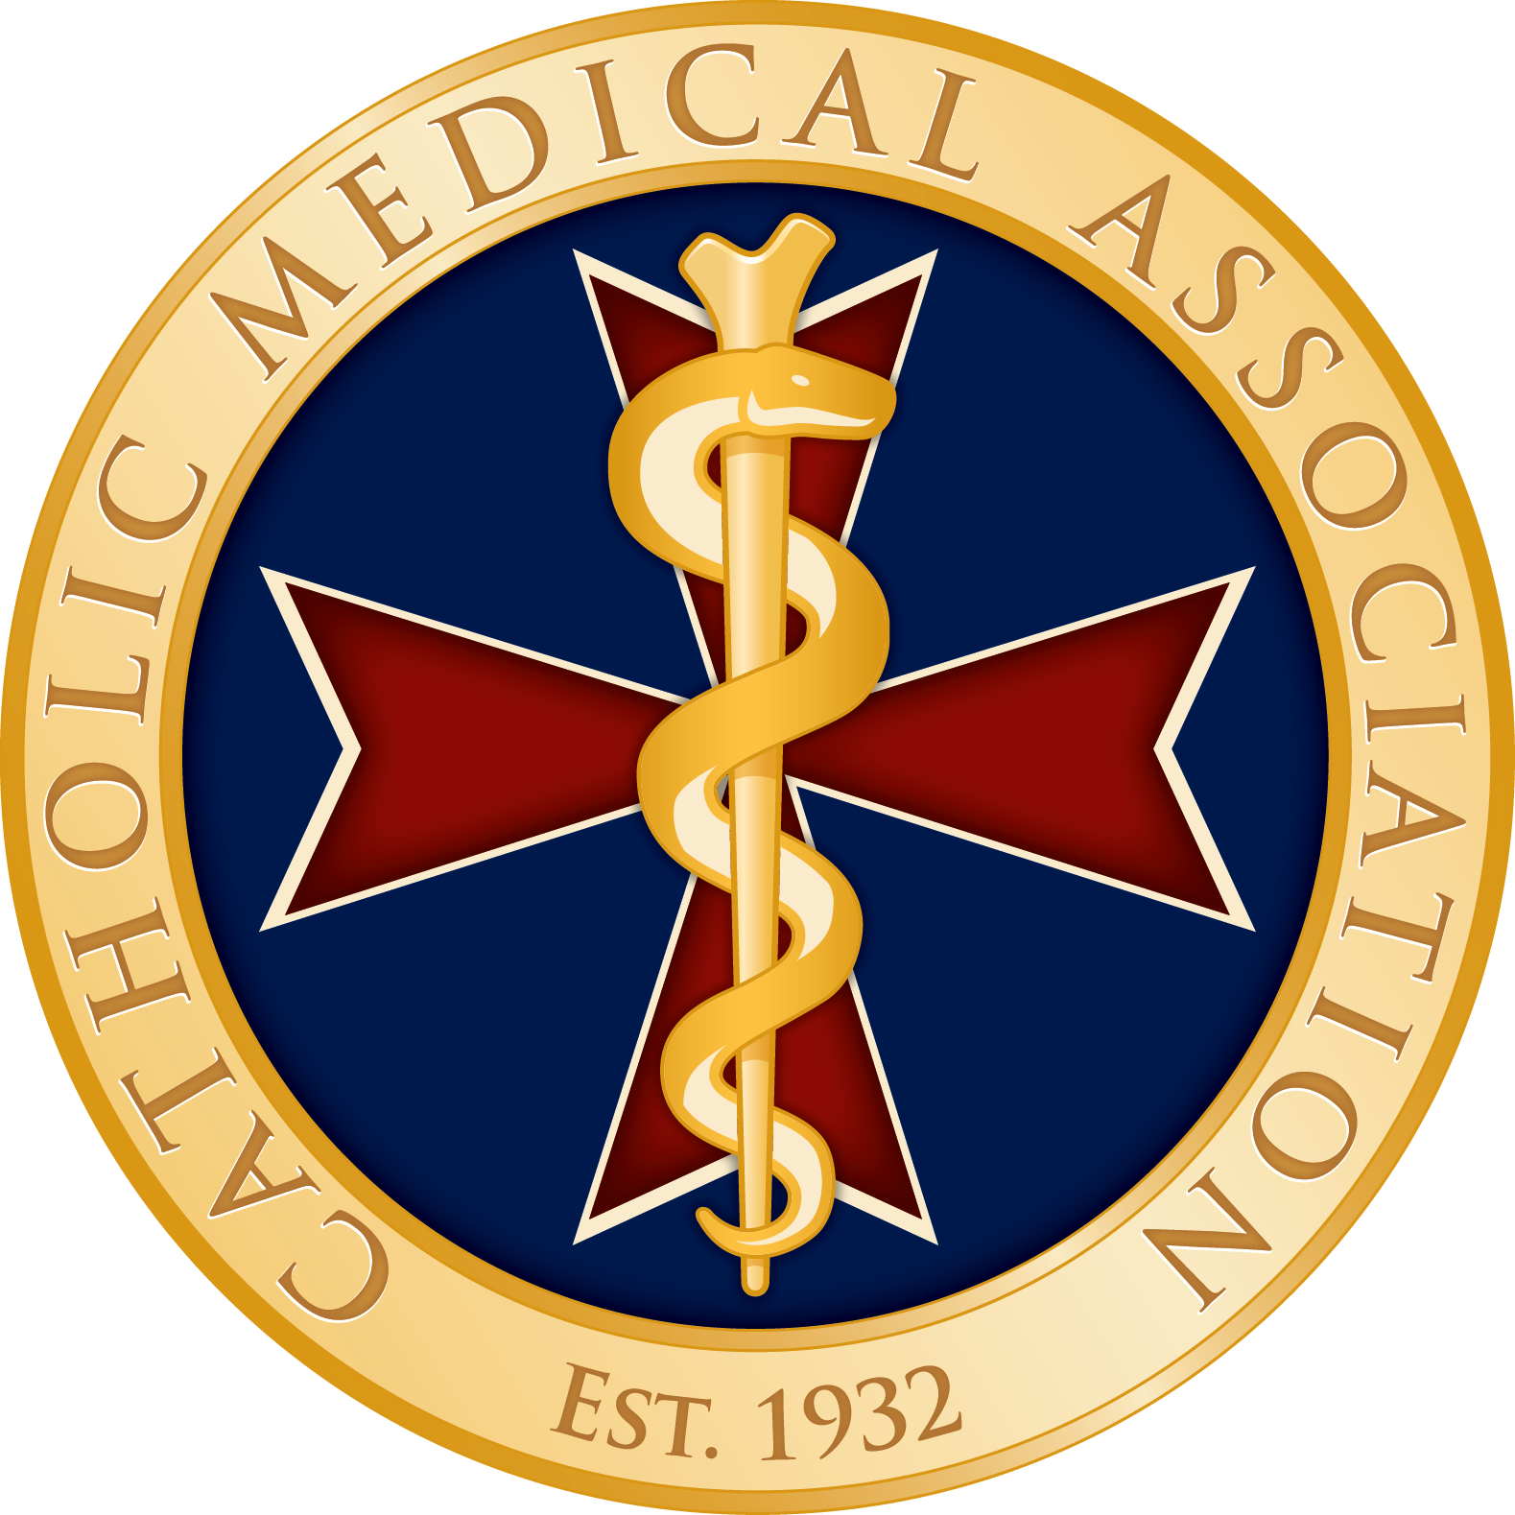 

July 21, 2020

Most Rev. Joseph F. Naumann

Archbishop of Kansas City, Kansas

Chairman, USCCB Committee on Pro-Life Activities

3211 Fourth Street, N.E.

Washington DC 20017-1194

Your Excellency:

We are writing to you as the leaders of two organizations dedicated to the faithful application of Catholic moral principles in the fields of health care, the life sciences, and research. In April 2018, we corresponded with your predecessor, Timothy Cardinal Dolan, then Chairman of the USCCB Committee on Pro-Life Activities, regarding the importance of a new vaccine for shingles (Shingrix) that did not rely on aborted fetal cell lines (AFCL) in its development, or use of AFCLs in the production process. We are writing to report a similar and welcome development that provides an opportunity to advocate for a culture of life in America.

The key development involves Sanofi-Pasteur, one of the three largest vaccine manufacturers in the world. Recently Sanofi-Pasteur: (1) ended production of one vaccine (Poliovax) which was produced using aborted fetal cell line MRC-5; (2) ended use of MRC-5 in two current important pediatric vaccines (Pentacel and Quadracel); and (3) began development of a vaccine for COVID-19 which will not make use of AFCLs.

These steps by Sanofi-Pasteur are significant for at least four reasons: First, ending production of Poliovax reduces the number of vaccines that employ AFCLs. Second, the changes made to Pentacel and Quadracel mean that Catholic and pro-life parents will face fewer ethical dilemmas when having their children vaccinated based on current standards. Third, Sanofi-Pasteur’s actions demonstrate that it is possible to make safe and effective vaccines without resort to AFCLs, and even to remove AFCLs from vaccines currently in use. Finally, Sanofi-Pasteur’s approach to a vaccine for COVID-19 shows its commitment to developing future vaccines without resorting to use of AFCLs.

All of this is important because the exploitation of human beings following elective abortion for medical research and development is a serious attack on human dignity that has persisted for decades. It was explicitly condemned by *Dignitas Personae* in 2008. Yet too often people have been told that there is not much that can be done about the use of AFCLs in vaccines, particularly in pediatric vaccines. In addition, many politicians, scientists, and activists have cited the widespread acceptance of AFCL-dependent vaccines to argue that even more unethical research (e.g., to obtain human embryonic stem cells) can be justified or that abortion must remain legal so that scientists and corporations can access the tissue and organs they need for medical research and development. Sanofi-Pasteur’s actions show that moral and medical progress is possible. We should celebrate this and request—even demand—more from the pharmaceutical industry.

We encourage the Committee on Pro-Life Activities and individual bishops to seize this opportunity to educate Catholics about this important development and to encourage them to advocate for a culture of life. Such an effort could include:

1. Expressing appropriate gratitude to Sanofi-Pasteur for its steps on Poliovax, Pentacel, and Quadracel, as well as COVID-19 vaccine development, and encouraging Sanofi-Pasteur to develop additional vaccines not linked to elective abortion.
2. Reminding Catholics of their duty to use vaccines not linked to elective abortion whenever possible, and to pressure other pharmaceutical companies to produce more alternative vaccines not linked to elective abortion. This is particularly important at this time with regard to a vaccine for COVID-19;
3. Encouraging Catholic health care systems to preferentially purchase vaccines that do not rely on AFCLs and to use their purchasing power to create the market for the development of more vaccines not linked to elective abortion;

Thank you for your attention to this important issue. We stand ready to assist you in this effort in any way that we can.

Sincerely,

Michael Parker, M.D. Joseph Meaney, Ph.D. *President,* Catholic Medical Association *President,* The National Catholic Bioethics Center